Chapter 3 – Page 123 - #9

# Problem Statement

1 gallon of paint for every 115 square feet of wall space and it takes 8 hours to paint 1 gallon. The cost is $20/hour. Design a modular program to:

# Algorithm

1. Ask the user to enter the square feet of wall space to be painted (area)
2. Ask the user to enter the price of paint per gallon (price)
3. Display:
   1. Number of gallons of paint required
   2. Hours of labor required
   3. Cost of paint
   4. Labor charges
   5. Total cost of the paint job

# IPO Diagrams

Main module

|  |  |  |
| --- | --- | --- |
| Input | Processing | Output |
| area  price | Calculate paintCost = Call paint(area, price)  Calculate laborCost = Call labor(area)  Call total(paintCost, laborCost)  Calculate total = paintCost + laborCost | Display total |

Paint module

|  |  |  |
| --- | --- | --- |
| Input | Processing | Output |
| area  price | Calculate numGallons = area / 115  Calculate paintCost = numGallons * price | Display numGallons  Display paintCost  Return paintCost |

Labor module

|  |  |  |
| --- | --- | --- |
| Input | Processing | Output |
| area | Calculate numGallons = area / 115  Calculate hours = numGallons * 8  Calculate laborCost = hours * $20 | Display hours  Display laborCost  Return laborCost |

# Hierarchy Chart

# Flowchart

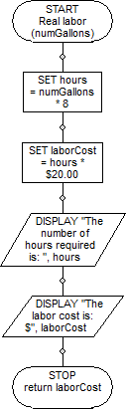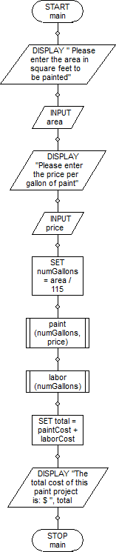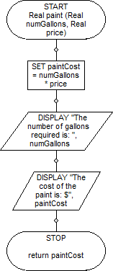

# Pseudocode

// Program: Ch3-P123-#9

// Author: Mark Doctor

// Course: iTech

void main ()

{

DISPLAY " Please enter the area in square feet to be painted";

INPUT area;

DISPLAY "Please enter the price per gallon of paint";

INPUT price;

SET numGallons = area / 115;

paint (numGallons, price);

labor (numGallons);

SET total = paintCost + laborCost;

DISPLAY "The total cost of this paint project is: $", total;

}

Real paint (Real numGallons, Real price)

{

SET paintCost = numGallons * price;

DISPLAY "The number of gallons required is: ", numGallons;

DISPLAY "The cost of the paint is: $", paintCost;

return paintCost;

}

Real labor (numGallons)

{

SET hours = numGallons * 8;

SET laborCost = hours * $20.00;

DISPLAY "The number of hours required is: ", hours;

DISPLAY "The labor cost is: $", laborCost;

return laborCost;

}

# Java Source Code

1 //Mark Doctor, 9/28/16, iTechPM - 2nd class meeting  
 2 //Purpose: Learn modular programming  
 3 //Filename: PaintJob.java  
 4 //Documentation: Chapter 3 - P123 - #9 MDoctor.docx  
 5   
 6 import java.util.*;  
 7 import java.text.DecimalFormat;  
 8 public class PaintJob  
 9 {  
10 //Global Constants  
11 public static final double FT_GAL = 115.0;  
12 public static final double HRS_PAINT = 8.0;  
13 public static final double RATE_HR = 20.00;  
14 public static DecimalFormat df = new DecimalFormat("#.00");  
15   
16 public static void main(String[] args)  
17 {  
18 //Variable Declarations  
19 Scanner keyboard = new Scanner(System.in);  
20 double area, price, numGallons, paintCost, laborCost, total;  
21   
22 //Prompt and collect area and price and calculate numGallons  
23 System.out.println("Please enter the area in square feet to be painted: ");  
24 area = keyboard.nextDouble();  
25 System.out.println("Please enter the price per gallon of paint: ");  
26 price = keyboard.nextDouble();  
27 numGallons = area /115;  
28   
29 //Calculate paintCost and laborCost by calling paint() and labor()  
30 paintCost = paint(numGallons, price);  
31 laborCost = labor(numGallons);  
32   
33 //Calculate and display total  
34 total = paintCost + laborCost;  
35 System.out.println("The total cost of this paint project is: $" + df.format(total));  
36   
37 }//end of main  
38   
39   
40 //Calculates paintCost and prompts user on numgallons and paintCost  
41 public static double paint(double numGallons,double price)   
42 {  
43 double paintCost = numGallons * price;  
44 System.out.println("The number of gallons required is: " + df.format(numGallons));  
45 System.out.println("The cost of the paint is: $" + df.format(paintCost));  
46 return paintCost;  
47 }//end of paint  
48   
49 //Calculates hours and laborCost and prompts user on required hours and laborCost  
50 public static double labor(double numGallons)  
51 {  
52 double hours = numGallons * HRS_PAINT;  
53 double laborCost = hours * RATE_HR;  
54 System.out.println("The number of hours required is: " + df.format(hours));  
55 System.out.println("The labor cost is $" + df.format(laborCost));  
56 return laborCost;  
57 }//end of labor   
58 }//end of class  
59 /*  
60  ----jGRASP exec: java PaintJob  
61 ▪Please enter the area in square feet to be painted:   
62 ▪500  
63 ▪Please enter the price per gallon of paint:   
64 ▪50  
65 ▪The number of gallons required is: 4.35  
66 ▪The cost of the paint is: $217.39  
67 ▪The number of hours required is: 34.78  
68 ▪The labor cost is $695.65  
69 ▪The total cost of this paint project is: $913.04  
70 ▪  
71  ----jGRASP: operation complete.  
72   
73 */